**Prescribing Tip No. 292 Date: 10th July 2020**

**EPS Phase 4**

**What is EPS Phase 4?**

[**EPS Phase 4**](https://www.emisnow.com/csm?id=kb_article&sysparm_article=KB0045831)is the point at which electronic prescriptions become the default for prescribing, dispensing and processing claims for Primary Care prescriptions in England. EPS has a number of benefits, including:

* almost ***all*** prescriptions **will be processed and signed electronically** – in most cases, over 95% of prescriptions will be processed this way and only a small proportion will be hand-signed.
* one main process for prescriptions will lead to a **more efficient, faster and secure service.**
* if a patient without an EPS nomination loses their token, it can easily be reprinted – there is **no need to re-issue** the electronic prescription.
* **it is also possible to track** more prescriptions using the [**EPS Prescription Tracker**](https://digital.nhs.uk/services/electronic-prescription-service/about-the-eps-prescription-tracker)

Since the onset of the Covid-19 pandemic, practices across both our CCG localities have been working extremely hard to ensure that all appropriate patients nominate a Community Pharmacy/ DAC. More than 28 million patients in England now have a nomination on their PMR record. **Patients without a nomination** will automatically have their prescriptions sent electronically. A token (patients may refer to this as a ‘paper copy’) **must always be printed** for these patients, even if clinicians are prescribing remotely. **Without this token, patients will not be able to get their medication as the barcode needs to be scanned by the dispenser to retrieve the prescription from the NHS Spine**.

**EPS Phase 4 tokens during the COVID-19 pandemic**

During the pandemic, the aim is to reduce the number of patients needing to visit their GP practice, it is possible for the patient to collect their prescription by providing their NHS Number or token ID at the pharmacy. **Please ensure the patient knows their NHS Number or has a copy of the token ID when issuing an electronic prescription.**

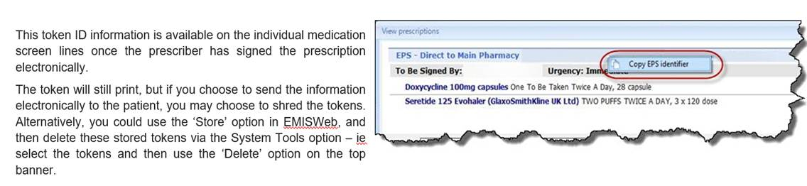

Further information can be found within this GP practice fact sheet, produced by NHS Digital 

**Activating EPS Phase 4**

Before EPS Phase 4 can be activated for your organisation, the practice needs to complete the following:

1. Read the NHS Digital site readiness [**checklist**](https://digital.nhs.uk/binaries/content/assets/website-assets/services/electronic-prescription-service/eps-phase-4-site-readiness-checklist.pdf) to understand any new processes that may need to be considered.
2. Complete the form [**here**](https://www.emisnow.com/csm?id=sc_cat_item&sys_id=2e81aa5f1bfbc8507937a8a4bd4bcbee)**,** requesting that EPS Phase 4 be activated. (This will require the approval of a clinician at your organisation. When completing the form, you will be asked to provide your organisation ID. This can be found on the EMIS Web login page.)
3. EMIS will process your request and the practice will receive an email advising that EPS Phase 4 has been activated. The activation process can take up to two working days to complete, with the activation itself taking place overnight.

**Additional resources**

NHS Digital have created a suite of resources, including checklists and various templates that are available [**here**](https://digital.nhs.uk/services/electronic-prescription-service/phase-4/prescriber-information#communication-resources)**.**

If you have any further queries with regards to site readiness and preparation, **please contact the Medicines Optimisation Team via 01772 214302**